Grammer (ProjLang.g)

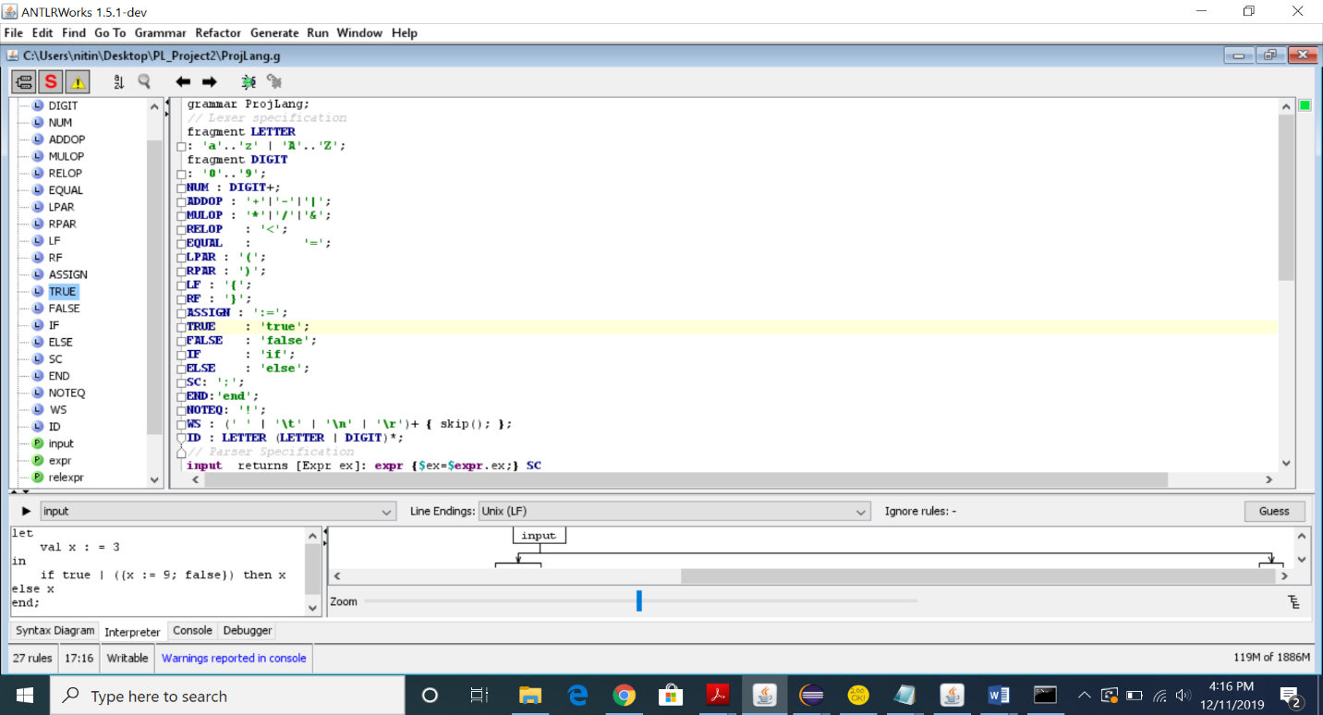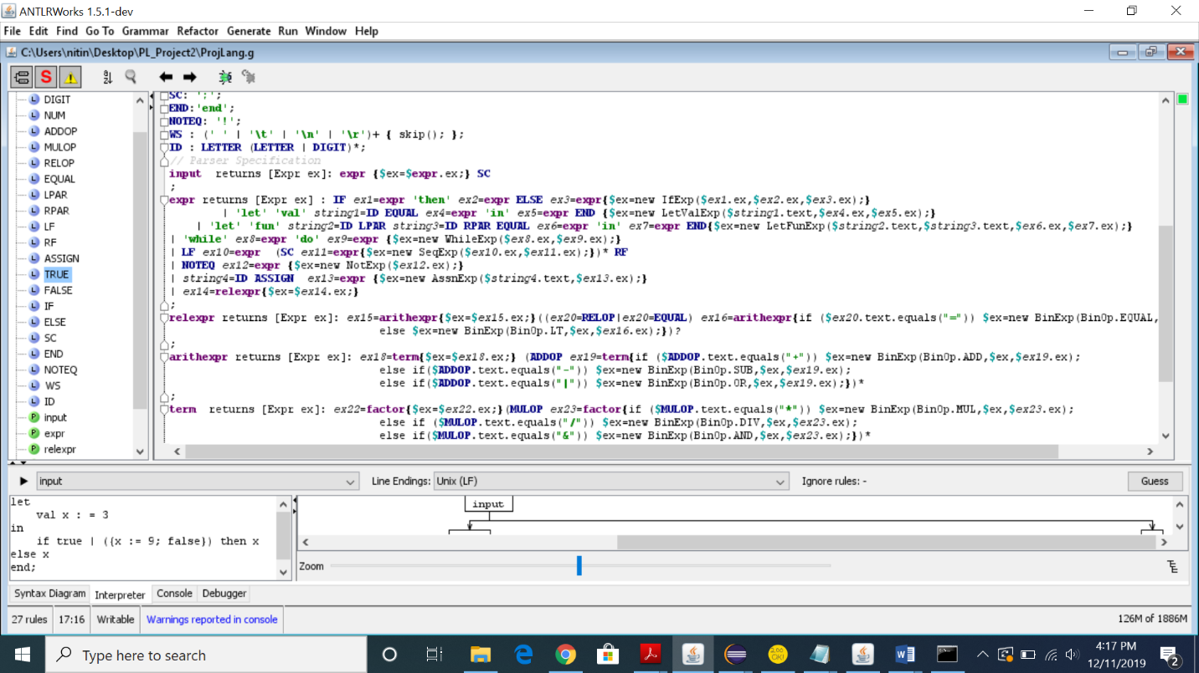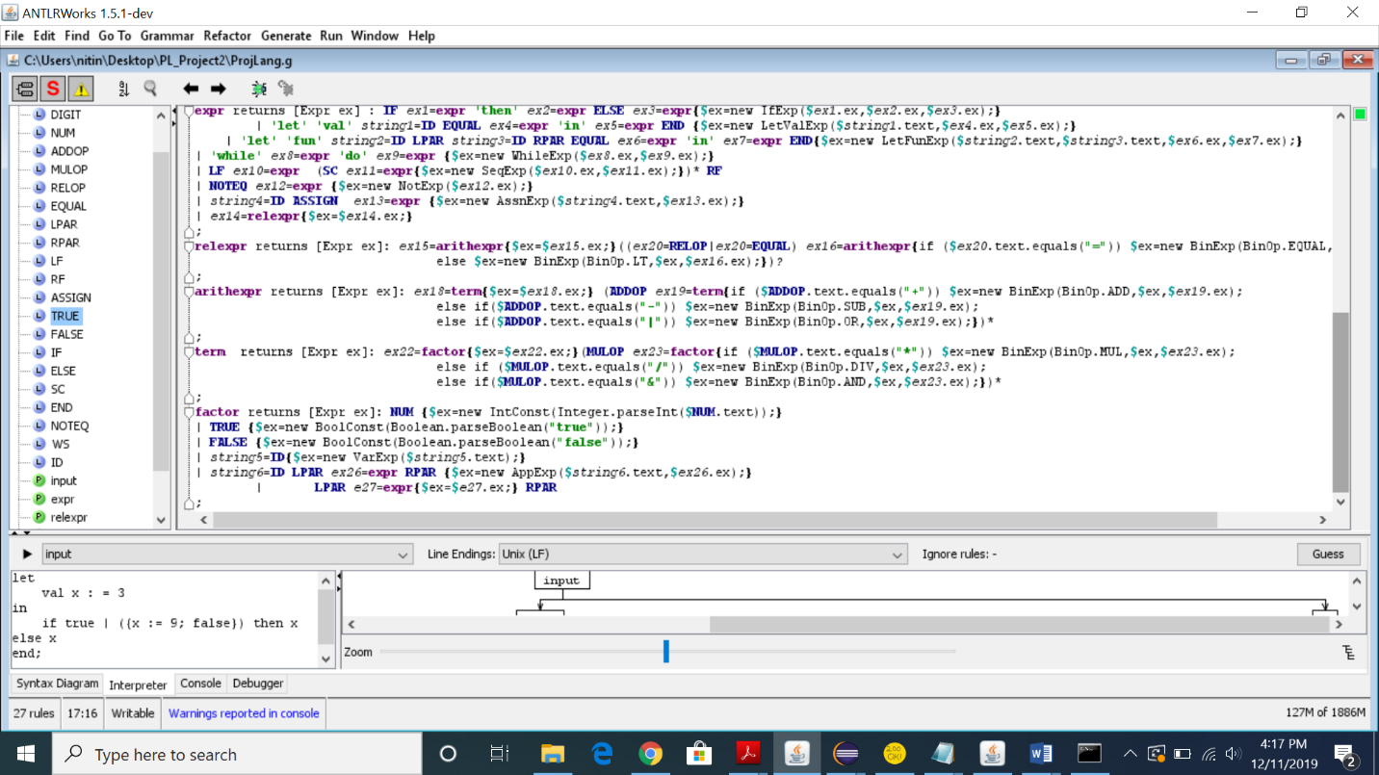

Parse Trees:

**Let Val Expression:**

let val x=8 in while x < 100 do x := x * 2 end; 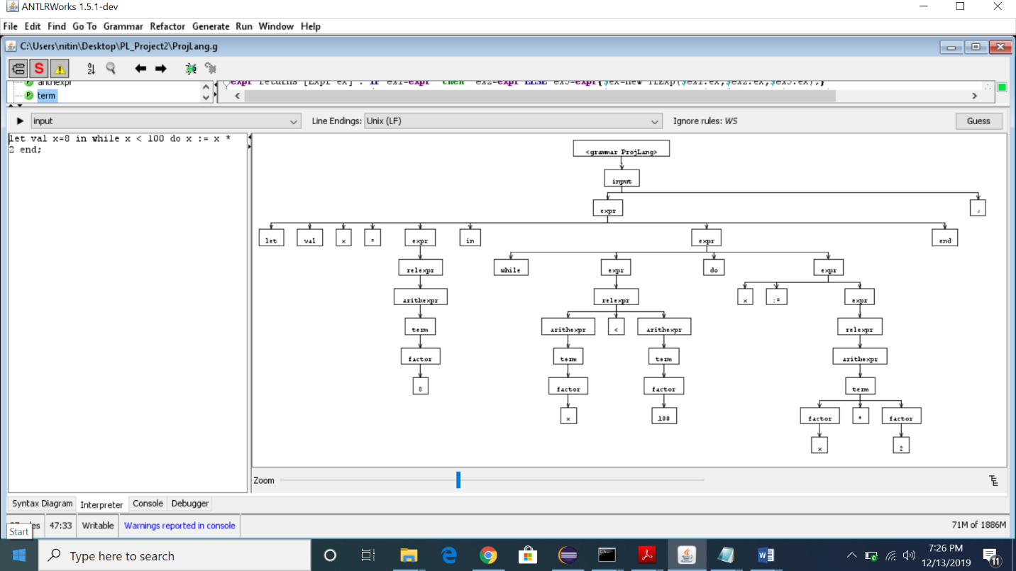

**Let Fun Expression:**

let fun add(x) = x + x in add(2) end;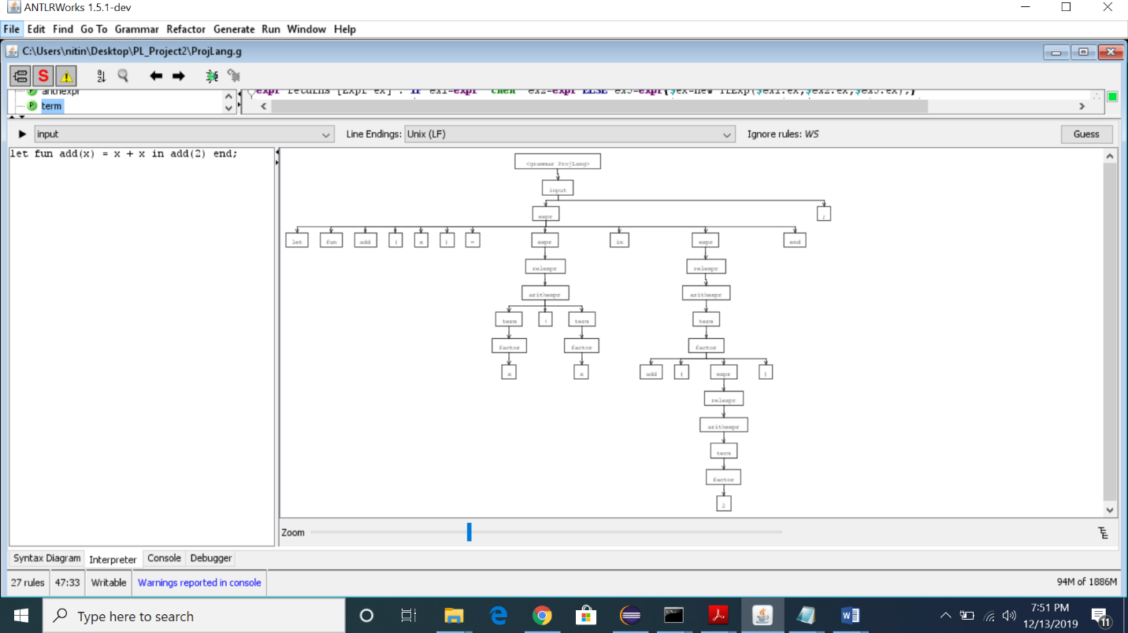

**Sequence Exp:**

{1+2;3+5*6+7};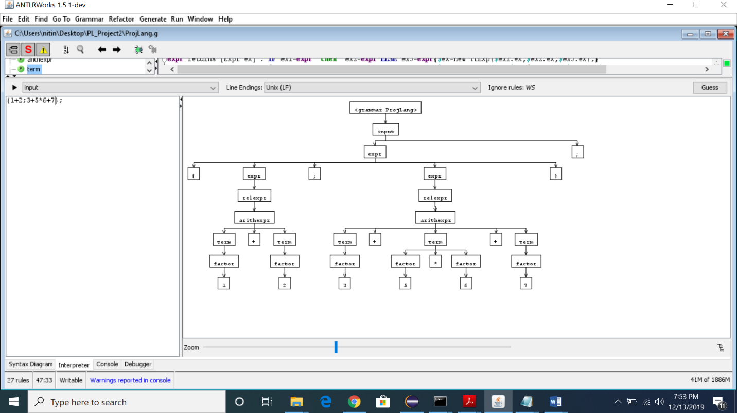

**If Expression:**

if 1<2 then true else false;

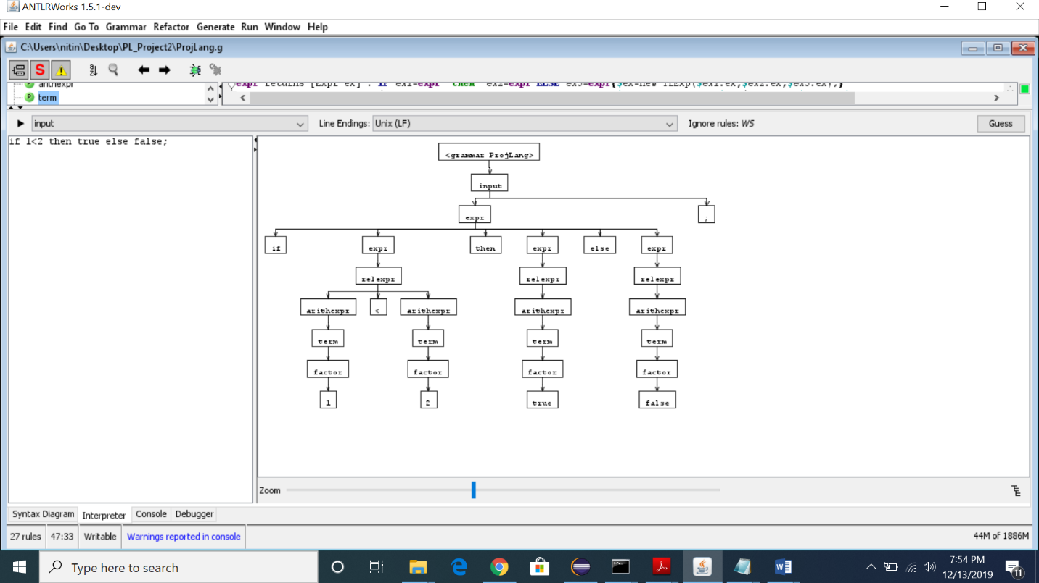

**Not Expression:**

**!true;**

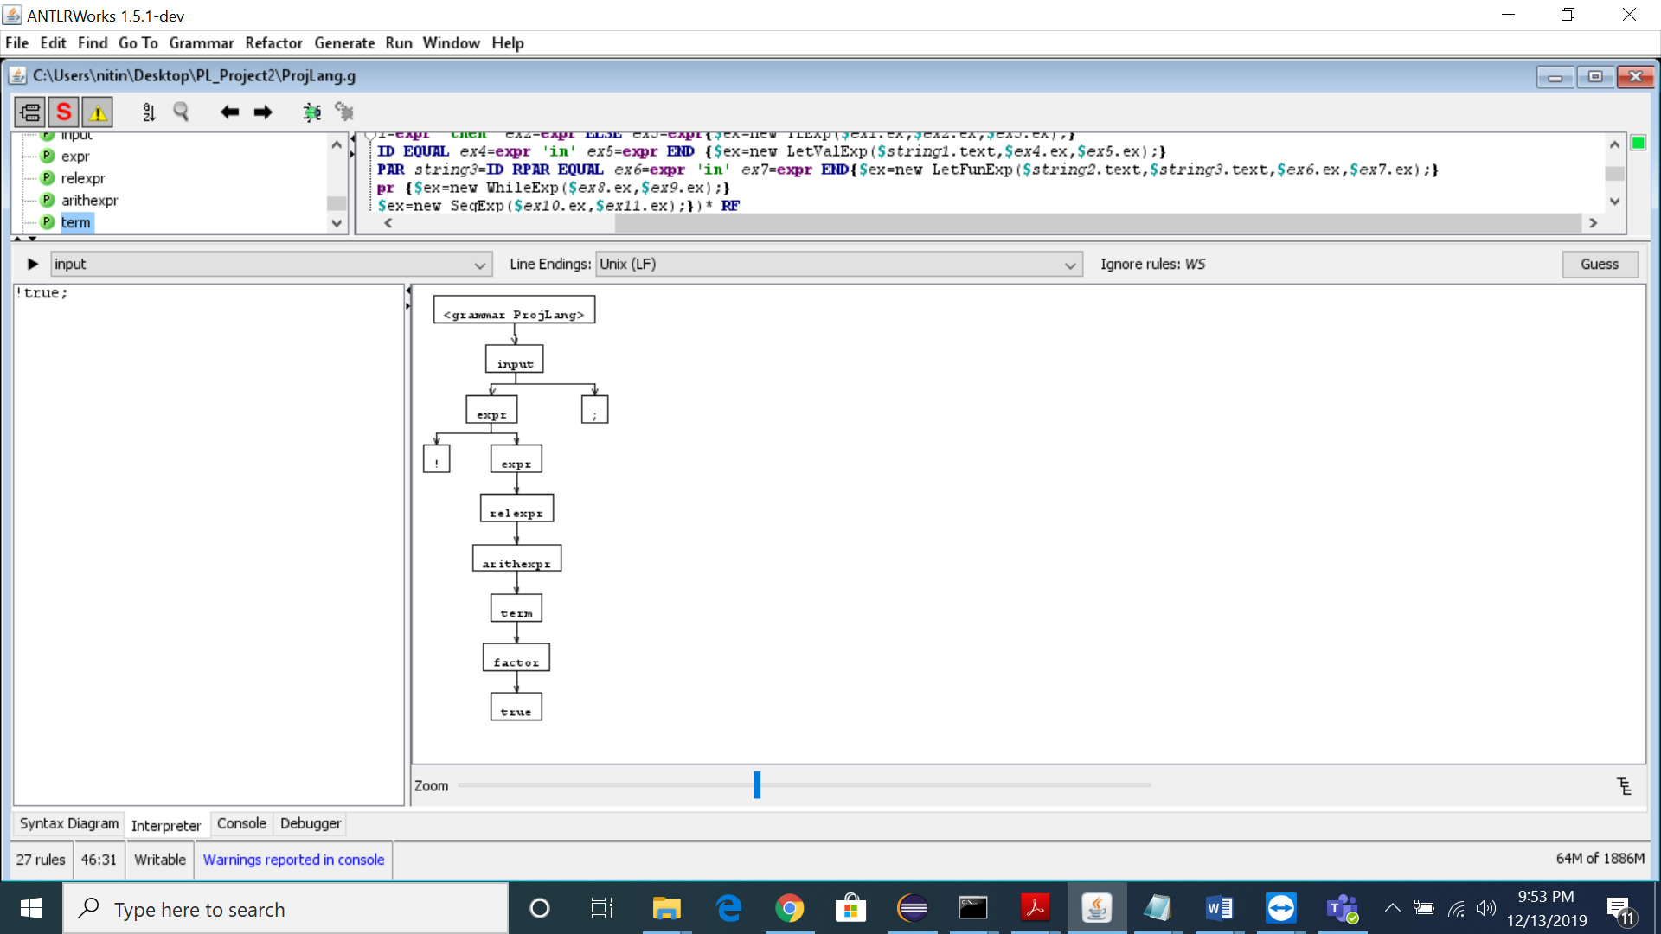

**While Expression:**

let fun f(x) = ( while x = 1 do x := x- 1 ) in f(1) end;

